My ref:
Your ref:
Date: | Thursday 5th November 2015
Contact: | Jeremy Smith
Direct dial:
E Mail: | city.deal@cambridgeshire.gov.uk
 | By Email

Cambridge congestion: Call for Evidence Launch Event 11th November 2015
Dear Sir/Madam
Further to my letter of 29th October, notifying you of the Call for Evidence on how best to tackle congestion in Cambridge, I am now writing to invite you to attend our launch event on Wednesday 11th November, from 6-8pm, at The Small Hall, The Guildhall, Market Square, Cambridge, CB2 3QJ.
This is a public event, and one which we would be delighted if you could attend.
Further to the launch event, the times, dates and venues of the public hearing sessions are confirmed as:

Call for Evidence 1
16 November 09:30 – 12:30

Conference Room,
Cambridge Central Library,
Lion Yard,
Cambridge
CB2 3QD

Call for Evidence 2
18 November 14:00 – 17:00

Swansley Room,
South Cambridgeshire Hall,
Cambourne,
Cambridge
CB23 6EA

Call for Evidence 3
30 November 09:30 – 12:30

Meadows Community Centre
1 St Catharine’s Road
Cambridge
CB4 3XJ

If you are interested in presenting your ideas at one of the public hearings, please notify us at city.deal@cambridgeshire.gov.uk by 9th November.
We hope to see you at the launch or one of the hearing sessions.
Yours sincerely,
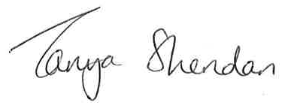
Tanya Sheridan
Greater Cambridge City Deal Programme Director

