The Federation of Cambridge Residents Associations (FeCRA) invite you to their 2018 Event.

Friday 20th April, 7.00 – 8.30 pm
The Perse School, Hills Road, Cambridge CB2 8QF

Making a Green City - George Ferguson

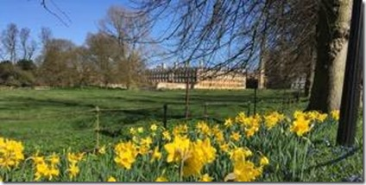

George Ferguson, city visionary and entrepreneur, former Mayor of Bristol and Chair of the Royal Institute of Architects (RIBA) will talk about ‘Making a Green City- What Can Cambridge Learn from Bristol?'
‘We shape our cities and thereafter they shape our children’- George Ferguson

In 2017 the Sunday Times described Bristol ‘as the best place to live in the UK’. In 2018 the Guardian reported that Bristol was standing up to developers. ‘We said it wasn’t acceptable’… ‘We’re a great city to do business in – but we want the right kind of money.’

As the first elected Mayor of Bristol, George Ferguson raised Bristol’s profile and introduced important green initiatives. He will be talking about these and the reaction to them.

What was their impact and could they work for Cambridge?

Find out from him and a panel of leading Cambridge experts.

Reserve your free place via Eventbrite http://bit.ly/2IuXhu6

